COMPUTER ORGANIZATION
&
ARCHITECTURE

LAB MANUAL

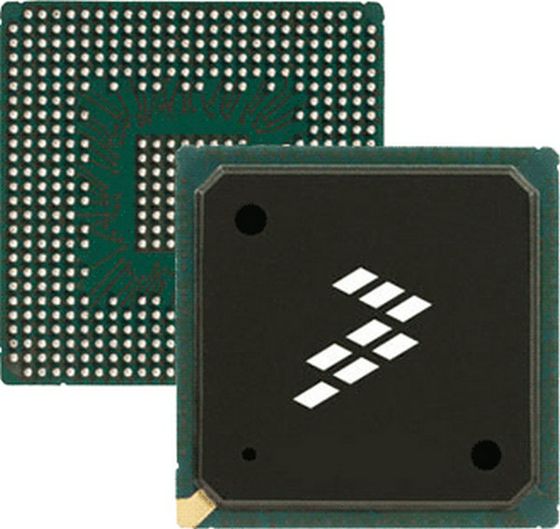

Prepared By: Engr. Salim Ullah
Revised By: Engr. Amaad Khalil (Fall 2015)

Department of computer systems engineering
University of engineering & technology Peshawar

List of Experiments

LAB No.1: Introduction to SPIM/QtSpim Simulator for the MIPS Assembly Language.
LAB No.2: MIPS ASSEMBLY
LAB No.3: Debugging Using Breakpoints, Single Step, Use of Loops & Conditional Statements
LAB No.4: Logical Instruction, Use of lo and hi Registers through, Multiplication and Division & Character Manipulation
LAB No.5: Character and String Manipulation, Arrays and Other Memory Operands
LAB No.6: Conversion of C Program to Assembly Language
LAB No.7: Floating Point Programming
LAB No.8: Floating Point Arithmetic

COMPUTER ORGANIZATION AND ARCHITECTURE

LAB 1

Introduction to SPIM Simulator for the MIPS Assembly Language

SPIM Simulator

SPIM is a simulator that runs programs for the MIPS R2000 R3000 RISC computers. It was developed by Professor Jame R. Larus SPIM, at University of Wisconsin, Madison. It can read and immediately execute files containing assembly language. SPIM is a self contained system for running these programs and contains a debugger and interface to a few operating system services. SPIM provides a simple terminal (command line version) and an X-window interface for UNIX. Both provide equivalent functionality, but the X interface is generally easier to use and more informative. Windows first version of SPIM was PCSPIM. Latest version is QtSpim. You can start QtSpim by start>programs>QtSpim or by writing the command QtSpim in run. When QtSpim starts up, it brings up a large window on your screen (see Figure 1). The large section in the middle of the application window is the window display section. There are four display windows: Registers, Text Segment, Data Segment, and Messages.

The following list describes each display window.
- The Register window display shows the values of all registers in the MIPS CPU and FPU.
- The Text Segment window display shows instructions both from your program and the system code that is loaded automatically when QtSpim is running.
- The Data Segment window display shows the data loaded into your program’s memory and the data of the program’s stack.
- The Messages window display is the location where QtSpim uses to write messages. This is where error messages appear.

We will come back to SPIM on page 4, where we will discuss how to load and run an assembly file. First let us discuss something about the assembly and processor (MIPS).

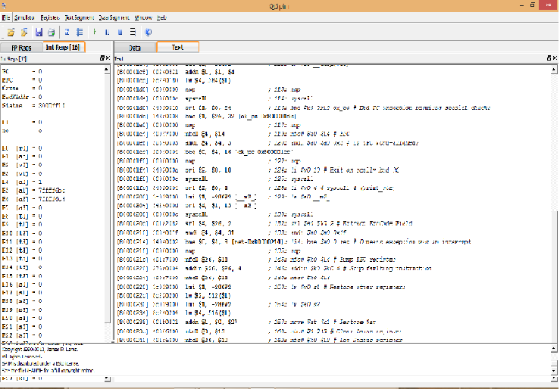
Register window
Data Segment window
Text Segment window
Message window
Figure1: QtSpim window interface

Intro to MIPS Assembly

Comments: Any line started with pound (#) sign. Without comments it is extremely difficult and dangerous to understand assembly program.

It’s a good practice to start program like this
-----------------------------------------------------------------------------------------------------
# Name of the programmer -- 04/10/2014
# add.asm-- A program that computes the sum of 1 and 2,
# leaving the result in register $t0.
# Registers used:
# t0 -used to hold the result.
# end of add.asm
-----------------------------------------------------------------------------------------------------

Even though the above program is doing nothing but it is very clear from the above lines that what the program will do.

Example1: add.asm
The add operation takes three operands:
- A register that will be used to store the result of the addition. For our program, this will be $t0.
- A register which contains the first number to be added. We select $t1, and make note of this in the comments.
- A register which holds the second number, or a 32-bit constant. In this case, since 2 is a constant that fits in 32 bits, we can just use 2 as the third operand of add.
We now know how we can add the numbers, but we have to figure out how to get 1 into register $t1. To do this, we can use the li (load immediate value) instruction, which loads a 32-bit constant into a register.
---------------------------------------------------------------------------------------------------------
# Name of the programmer -- 04/10/2014
# add.asm-- A program that computes the sum of 1 and 2,
# leaving the result in register $t0.
# Registers used:
# t0 -used to hold the result.
# t1 -used to hold the constant 1.

li $t1, 1 # load 1 into $t1.
add $t0, $t1, 2 # $t0 = $t1 + 2.

# end of add.asm
--------------------------------------------------------------------------------------------------------

These two instructions perform the calculation that we want, but they do not form a complete program. Much like C, an assembly language program must contain some additional information that tells the assembler where the program begins and ends.

In SPIM, program execution begins at the location with the label main. A label is a symbolic name for an address in memory. In MIPS assembly, a label is a symbol name followed by a colon. Labels must be the first item on a line.
---------------------------------------------------------------------------------------------------------
# Name of the programmer -- 04/10/2014
# add.asm-- A program that computes the sum of 1 and 2,
# leaving the result in register $t0.
# Registers used:
# t0 -used to hold the result.
# t1 -used to hold the constant 1.

main: # SPIM starts execution at main.
li $t1, 1 # load 1 into $t1.
add $t0, $t1, 2 # $t0 = $t1 + 2.
# end of add.asm
--------------------------------------------------------------------------------------------------------
The end of a program is defined in a very different way. Similar to C, where the exit function can be called in order to halt the execution of a program, one way to halt a
MIPS program is with something analogous to calling exit in C. Unlike C, however, if you forget to “call exit” your program will not gracefully exit when it reaches the end of the main function. Instead, it will blunder on through memory, interpreting whatever it finds as instructions to execute. Generally speaking, this means that if you are lucky, your program will crash immediately; if you are unlucky, it will do something random and then crash.
The way to tell SPIM that it should stop executing your program, and also to do a number of other useful things, is with a special instruction called a syscall. The syscall instruction suspends the execution of your program and transfers control to the operating system. The operating system then looks at the contents of registers $v0 to determine what it is that your program is asking it to do. To exit the program instruction li is used to load value 10 (code for exit) to $v0 before executing syscall instruction.

---------------------------------------------------------------------------------------------------------
# Name of the programmer -- 07/10/2014
# add.asm-- A program that computes the sum of 1 and 2,
# leaving the result in register $t0.
# Registers used:
# t0 -used to hold the result.
# t1 -used to hold the constant 1.
# v0 -syscall parameter.

main: # SPIM starts execution at main.

li $t1, 1 # load 1 into $t1.
add $t0, $t1, 2 # compute the sum of $t1 and 2, and put it into $t0.

li $v0, 10 # syscall code 10 is for exit.
syscall # make the syscall.

# end of add.asm
--------------------------------------------------------------------------------------------------------

Using SPIM
At this point, we should have a working program. Now, it’s time to try running it to see what happens. To run SPIM, simply enter the command QtSpim at the run from start menu. Whenever you see the (spim) prompt, you know that SPIM is ready to execute a command. In this case, since we want to run the program that we just wrote, the first thing we need to do is to load the file containing the program. This is done by going through File>Open.
The load operation reads and assembles a file containing MIPS assembly language, and then loads it into the SPIM memory. If there are any errors during the assembly, error messages with line number are displayed. You should not try to execute a file that has not loaded successfully– SPIM will let you run the program, but it is unlikely that it will actually work.
Once the program is loaded, you can run it by going to Simulator>Go or press F5 key on the keyboard. Since our program is supposed to leave its result in register $t0, we can verify that the program is working by asking SPIM, using the print command, to print out the contents of $t0.

Example 2: add2.asm
Compute the sum of two numbers specified by the user at runtime, and displays the result on the screen
The algorithm this program will follow is:
- Read the two numbers from the user. We’ll need two registers to hold these two numbers. We can use $t0 and $t1 for this.
- Compute their sum. We’ll need a register to hold the result of this addition. We can use $t2 for this.
- Print the sum.
- Exit. We already know how to do this, using syscall.

---------------------------------------------------------------------------------------------------------
# Name of the programmer -- 07/10/2014
# # add2.asm-- A program that computes and prints the sum
# of two numbers specified at runtime by the user.
# Registers used:
# $t0 -used to hold the first number.
# $t1 -used to hold the second number.
# $t2 -used to hold the sum of the $t1 and $t2
# $v0 -syscall parameter.
main:
## Get first number from user, put into $t0.
## Get second number from user, put into $t1.

add $t2, $t0, $t1 # compute the sum.

## Print out $t2.
li $v0, 10 # syscall code 10 is for exit.
syscall # make the syscall.
# end of add2.asm.
--------------------------------------------------------------------------------------------------------

Reading and Printing Integers
To read number from user and print out the sum, syscall is used. syscall 5 can be used to read an integer into register $v0, and syscall 1 can be used to print out the integer stored in $a0.
Register $v0 is not a recommended place to keep anything, so we have to move the data to another register through move instruction.

---------------------------------------------------------------------------------------------------------
# Name of the programmer -- 07/10/2014
# add2.asm-- A program that computes and prints the sum
# of two numbers specified at runtime by the user.
# Registers used:
# $t0 -used to hold the first number.
# $t1 -used to hold the second number.
# $t2 -used to hold the sum of the $t1 and $t2.
# $v0 -syscall parameter and return value.
# $a0 -syscall parameter.

main:
## Get first number from user, put into $t0.
li $v0, 5 # load syscall read_int into $v0.
syscall # make the syscall.
move $t0, $v0 # move the number read into $t0.

## Get second number from user, put into $t1.
li $v0, 5 # load syscall read_int into $v0.
syscall # make the syscall.
move $t1, $v0 # move the number read into $t1.
add $t2, $t0, $t1 # compute the sum.

## Print out $t2.
move $a0, $t2 # move the number to print into $a0.
li $v0, 1 # load syscall print_int into $v0.
syscall # make the syscall.

li $v0, 10 # syscall code 10 is for exit.
syscall # make the syscall.
# end of add2.asm
---------------------------------------------------------------------------------------------------

SPIM syscalls
SPIM provides a small set of operating system like services through the system call (syscall) instruction. To request a service, a program loads the system call code into register $v0 and the arguments into registers $a0,….$a3 (or $f12 for floating point values). System calls that return values put their result in register $v0 (or $f0 for floating point results). For example, to print “the answer = 5”, use the commands:

.data
str: .asciiz “the answer = “
.text

li $v0, 4 # system call code for print_str
la $a0, str # address of string to print
syscall # print the string

li $v0, 1 # system call code for print_int
li $a0, 5 # integer to print
syscall # print it

Registers Details:
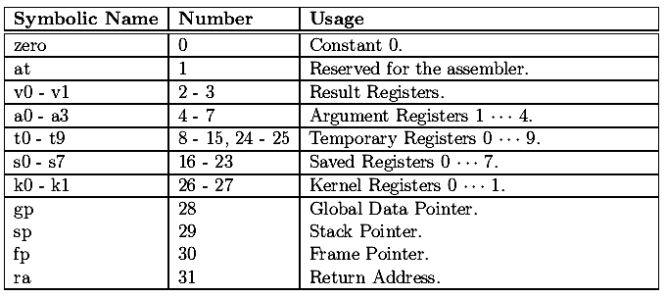

SPIM Assembler
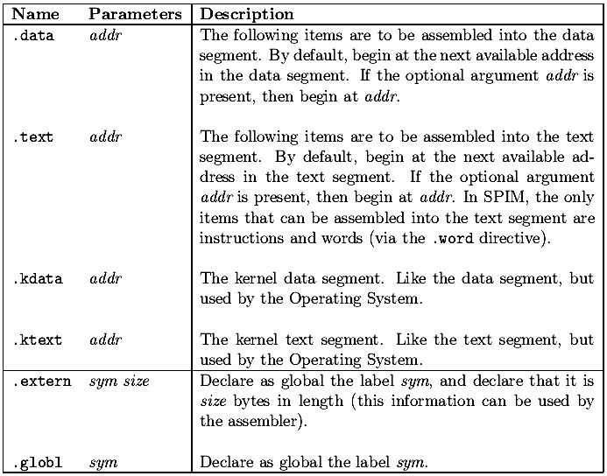

SPIM data directives:
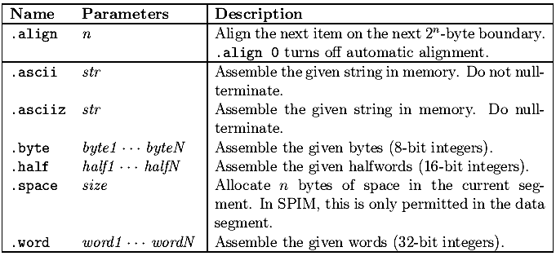

syscalls:
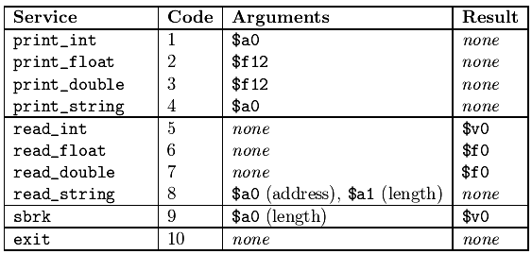

Registers detail:
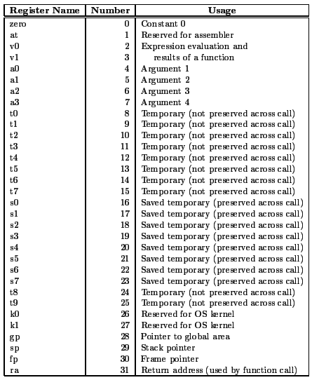

COMPUTER ORGANIZATION AND ARCHITECTURE

LAB 2: MIPS Assembly

SPIM syscalls
SPIM provides a small set of operating system like services through the system call (syscall) instruction. To request a service, a program loads the system call code into register $v0 and the arguments into registers $a0,….,$a3 (or $f12 for floating point values). System calls that return values put their result in register $v0 (or $f0 for floating point results).
String can be displayed using syscall. All we need to do is to put the address of the string we want to print into register $a0, the constant 4 into $v0, and execute syscall. The only things that we don’t know how to do are how to define a string, and then how to determine its address.

Data and Text Segment (.data and .text)
The string "Hello World" should not be part of the executable part of the program (which contains all of the instructions to execute), which is called the text segment of the program. Instead, the string should be part of the data used by the program, which is, by convention, stored in the data segment. The MIPS assembler allows the programmer to specify which segment to store each item in a program by the use of several assembler directives.

To put something in the data segment, all we need to do is to put a .data before we define it. Everything between a .data directive and the next .text directive (or the end of the file) is put into the data segment. Note that by default, the assembler starts in the text segment, which is why our earlier programs worked properly even though we didn’t explicitly mention which segment to use. In general, however, it is a good idea to include segment directives in your code, and we will do so from this point on.

We also need to know how to allocate space for and define a null-terminated string. In the MIPS assembler, this can be done with the .asciiz (ASCII, zero terminated string) directive. For a string that is not null-terminated, the .ascii directive can be used

# xxxxxxxxxxxx --- 12/10/2014
# hello.asm-- A "Hello World" program.
# Registers used:
# $v0 - syscall parameter and return value.
# $a0 - syscall parameter-- the string to print.
.text
main:
la $a0, hello_msg # load the addr of hello_msg into $a0.
li $v0, 4 # 4 is the print_string syscall.
syscall # do the syscall.

li $v0, 10 # 10 is the exit syscall.
syscall # do the syscall.

# Data for the program:
.data
hello_msg: .asciiz "Hello World\n"
# end hello.asm

Note that data in the data segment is assembled into adjacent locations. Therefore, there are many ways that we could have declared the string "Hello World\n" and gotten the same exact output. For example we could have written our string as:
.data
hello_msg: .ascii "Hello" # The word "Hello"
.ascii " " # the space.

.ascii "World" # The word "World"
.ascii "\n" # A newline.
.byte 0 # a 0 byte.
If we were in a particularly cryptic mood, we could have also written it as:
.data
hello_msg: .byte 0x48 # hex for ASCII "H"
.byte 0x65 # hex for ASCII "e"
.byte 0x6C # hex for ASCII "l"
.byte 0x6C # hex for ASCII "l"
.byte 0x6F # hex for ASCII "o"
... # and so on...
.byte 0xA # hex for ASCII newline
.byte 0x0 # hex for ASCII NUL
You can use the .data and .text directives to organize the code and data in your programs in whatever is most stylistically appropriate. The example programs generally have the all of the .data items defined at the end of the program, but this is not necessary. For example, the following code will assemble to exactly the same program as our original hello.asm:

.text # put things into the text segment...
main:
.data # put things into the data segment...
hello_msg: .asciiz "Hello World\n"
.text # put things into the text segment...
la $a0, hello_msg # load the addr of hello_msg into $a0.
li $v0, 4 # 4 is the print_string syscall.
syscall # do the syscall.

li $v0, 10 # 10 is the exit syscall.
syscall # do the syscall.

Conditional Execution: the larger Program
The next program that we will write will explore the problems of implementing conditional execution in MIPS assembler language. The actual program that we will write will read two numbers from the user, and print out the larger of the two.
One possible algorithm for this program is exactly the same as the one used by add2.asm, except that we’re computing the maximum rather than the sum of two numbers. Therefore, we’ll start by copying add2.asm, but replacing the add instruction with a placeholder comment:

# xxxxxxxxxxxxxxx – 12/10/2014
# larger.asm-- prints the larger of two numbers specified
# at runtime by the user.
# Registers used:
# $t0 - used to hold the first number.
# $t1 - used to hold the second number.
# $t2 - used to store the larger of $t1 and $t2.
.text
main:
## Get first number from user, put into $t0.
li $v0, 5 # load syscall read_int into $v0.
syscall # make the syscall.

move $t0, $v0 # move the number read into $t0.

## Get second number from user, put into $t1.
li $v0, 5 # load syscall read_int into $v0.
syscall # make the syscall.

move $t1, $v0 # move the number read into $t1.
## put the larger of $t0 and $t1 into $t2.
## (placeholder comment)

## Print out $t2.
move $a0, $t2 # move the number to print into $a0.
li $v0, 1 # load syscall print_int into $v0.
syscall # make the syscall.

## exit the program.
li $v0, 10 # syscall code 10 is for exit.
syscall # make the syscall.
# end of larger.asm.
MIPS branching instructions allow the programmer to specify that execution should branch (or jump) to a location other than the next instruction. These instructions allow conditional execution to be implemented in assembler language. One of the branching instructions is bgt. The bgt instruction takes three arguments. The first two are numbers, and the last is a label. If the first number is larger than the second, then execution should continue at the label, otherwise it continues at the next instruction. The b instruction, on the other hand, simply branches to the given label.

These two instructions will allow us to do what we want. For example, we could replace the placeholder comment with the following:
# If $t0 > $t1, branch to t0_bigger,
bgt $t0, $t1, t0_bigger
move $t2, $t1 # otherwise, copy $t1 into $t2.
b endif # and then branch to endif
t0_bigger:
move $t2, $t0 # copy $t0 into $t2
endif:

If $t0 is larger, then execution will branch to the t0_bigger label, where $t0 will be copied to $t2. If it is not, then the next instructions, which copy $t1 into $t2 and then branch to the endif label, will be executed.
This gives us the following program:
# xxxxxxxxxxxxxxx – 12/10/2014
# larger.asm-- prints the larger of two numbers specified
# at runtime by the user.
# Registers used:
# $t0 - used to hold the first number.
# $t1 - used to hold the second number.
# $t2 - used to store the larger of $t1 and $t2.
# $v0 - syscall parameter and return value.
# $a0 - syscall parameter.

.text
main:
## Get first number from user, put into $t0.
li $v0, 5 # load syscall read_int into $v0.
syscall # make the syscall.

move $t0, $v0 # move the number read into $t0.
## Get second number from user, put into $t1.
li $v0, 5 # load syscall read_int into $v0.
syscall # make the syscall.

move $t1, $v0 # move the number read into $t1.
## put the larger of $t0 and $t1 into $t2.
bgt $t0, $t1, t0_bigger # If $t0 > $t1, branch to t0_bigger,
move $t2, $t1 # otherwise, copy $t1 into $t2.
b endif # and then branch to endif
t0_bigger:
move $t2, $t0 # copy $t0 into $t2
endif:

## Print out $t2.
move $a0, $t2 # move the number to print into $a0.
li $v0, 1 # load syscall print_int into $v0.
syscall # make the syscall.

## exit the program.
li $v0, 10 # syscall code 10 is for exit.
syscall # make the syscall.
# end of larger.asm.

Looping: the multiples Program
The next program that we will write will read two numbers A and B, and print out multiples of A from A to A×B. Since we already know how to read in numbers and print them out, we won’t bother to implement these steps here. We’ll just leave these as comments for now.
Algorithm: The multiples program.
1. Get A from the user.
2. Get B from the user. If B = 0, terminate.
3. Set sentinel value S = A×B.
4. Set multiple m = A.
5. Loop:
(a) Print m.
(b) If m = = S, then go to the next step.
(c) Otherwise, set m = m+A, and then repeat the loop.
6. Terminate

# xxxxxxxxxxxxxxx – 12/10/2014
# multiples.asm-- takes two numbers A and B, and prints out
# all the multiples of A from A to A * B.
# If B <= 0, then no multiples are printed.
# Registers used:
# $t0 - used to hold A.
# $t1 - used to hold B.
# $t2 - used to store S, the sentinel value A * B.
# $t3 - used to store m, the current multiple of A.

.text
main:
## read A into $t0, B into $t1 (omitted).

blez $t1, exit # if B <= 0, exit.
mul $t2, $t0, $t1 # S = A * B.
move $t3, $t0 # m = A
loop:

## print out $t3 (omitted)
beq $t2, $t3, endloop # if m == S, we’re done.
add $t3, $t3, $t0 # otherwise, m = m + A.

## print a space (omitted)
b loop
endloop:

## exit (omitted)

# end of multiples.asm

SPIM Assembler Directives

SPIM data directives:

COMPUTER ORGANIZATION AND ARCHITECTURE

LAB 3: Debugging Using Breakpoints, Single Step, Use of Loops & Conditional Statements

This lab assumes that you have an understanding of what assembly language is. It also assumes that you know the names of the general-purpose registers in the MIPS CPU.

TASKS
Perform the following groups of tasks:

Lab A1.asm

- Create a directory to hold the files for this lab.

- Launch your favorite editor and type the following program. Note that assembly language is free-form but it is a good idea to align the four fields (label, instruction, operand, comment) in order to enhance the program's readability:

.text
main: #---------------------------------------
addi $t0, $0, 60 # t0 = 60
addi $t1, $0, 7 # t1 = 7
add $t2, $t0, $t1 # t2 = t0+t1
#-----------------------------------------
addi $v0, $0, 1 # service #1
add $a0, $0, $t2 # printInt
syscall # do print
#-----------------------------------------
jr $ra # return

Save the program under the name: LabA1.asm.

- Launch SPIM. On a window station, run QtSpim and open the program using the File menu. This will not only read the program but also assemble it (translate it to machine language). Hence, if any statement were mistyped, the error would be reported at this stage.

- Run the program. Select Go from the Simulator menu (as a shortcut, you can click the Go icon in the toolbar or simply press F5). In both versions, a dialog window will pop to prompt for the starting set-up. Accept the defaults by clicking OK.

- There are two variants of the add instruction: one adds two registers and stores the sum in a third. The other adds a register and an immediate (a constant), and hence the 'i' suffix. Note also that add is sometimes used as an assignment statement (by adding to $0).

- One of the panes in the SPIM GUI shows the values of all registers. Verify that the value of $t0 is 60 (decimal) or 3c (hexadecimal). Verify also the values of $t1 and $t2.

- The value of register $v0 seems odd: the program stored 1 in it yet the register pane reports 10 for it! It must be that SPIM ran additional instructions after executing our program. To confirm, let us single-step through the program: re-open the program in order to load a fresh copy and re-initialize SPIM. Instead of running, single-step by pressing F10 (QtSpim).

- Each time you step, the statement highlighted in the text-segment pane is executed and the registers are updated. How many statements are executed before our program?

- Step through our program and watch the register pane. What is the value of $v0 immediately after the execution of our program has ended?

LabA2.asm

- Modify the program by adding a directive before the first statement and a label for the last statement:

.globl fini
.text
main: #---------------------
...
fini: jr $ra # return

Save the modified program as: LabA2.asm.

- Load a fresh copy of the program in SPIM and set a breakpoint at main and another one at fini. You do so using the Simulator menu in QtSpim. When you now run the program, it will pause at the beginning of our program (so that you can inspect the registers) and once again at the end. Breakpoints and single stepping can be used together to speed up program debugging: you set a breakpoint at the beginning of a segment of code and then single step through it.

- You can set a breakpoint at a statement even if it is not labelled. You do so by adding its address instead. The address of an instruction appears in the text-segment pane as the leftmost field (bracketed and prefixed by 0x to indicate it is in hexadecimal). You can copy it (with the 0x prefix but without the brackets) and paste it in the breakpoint dialog. Use this technique to set a breakpoint at the statement that computes $t2.

LabA3.asm

- Our program printed the output using service #1, which prints integers. Modify the program so it prints using service #11, which interprets and prints the contents of $a0 as a character. Save the modified program as: LabA3.asm. Run it and explain why the output became C.

LabA4.asm

- Revert back to LabA2.asm and save it as LabA4.asm. Modify it so that it prints the sum and the difference of $t0 and $t1 separated by a space. Use the sub instruction to subtract registers. In order to print a space delimiter, use service #11 with $a0 being the space character:

addi $a0, $0, ' '

(Alternatively, you can store 32 in $a0.) Run and verify that the output becomes:

67 53

LabA5.asm

- Revert back to LabA2.asm and save it as LabA5.asm. Rather than hard-coding the numbers in our program, let us read one of them from the user by using service #5, readInt. Replace the statement:

addi $t0, $0, 60 # t0 = 60

with:

addi $v0, $0, 5 # v0 = readInt
syscall
add $t0, $0, $v0

Notice that you must set $v0 to 5 prior to issuing syscall. Afterwards, the entered integer is returned to you in $v0. We copied the return to $t0 so that the rest of the
program can remain unchanged. Run the program and enter 10. Do you obtain the
expected output?

LabA6.asm

- Save LabA5.asm as LabA6.asm then modify it so that it processes the two numbers as follows:

if ($t0 = = $t1)
{
Print ($t0 + $t1);
}
else
{
Print ($t0 - $t1);
}

We can express this using a conditional transfer of control (a branch) and an unconditional one (a jump):

if ($t0 = = $t1) branch to XX;
print ($t0 - $t1);
jump to YY;
XX: print ($t0 + $t1);
YY: rest of program

The first instruction in the above pseudo-code can be realized using:

beq $t0, $t1, XX

The third instruction is realized using:

j YY

Run the program and verify that it works as expected. Note that beq (branch-on-
equal) is used for = = and bne (branch-on-not-equal) for !=.

LabA7.asm

- Save LabA6.asm as LabA7.asm then modify it so that it processes the two numbers as follows:

if ($t0 < $t1)
{
Print ($t0 + $t1);
}
else
{
Print ($t0 - $t1);
}

We can reduce a "less-than" test to a "not-equal" test by using the following instruction:

slt $x, $y, $z

It sets $x to 1 if $y < $z and sets it to zero otherwise. Using this "set-on-less-than" instruction, you can perform the above test using bne. Run the program and verify that it works as expected. Note that slt has an immediate variant (slti) that allows the third operand to be an immediate.

LabA8.asm

- Start fresh and create the program LabA8.asm with the following body (between main and fini):

addi $v0, $0, 1
add $a0, $0, $0
loop: slti $t9, $a0, 5
beq $t9, $0, fini
syscall
addi $a0, $a0, 1
j loop

It is important that you understand the program and attempt to predict its output before running. Save the program then run it and confirm or correct your prediction.

- Replace the statement before last in the above program with:

addi $a0, $0, 1

What will the output be in this case? Show that single stepping is ideally suited to debug such an error.

LabA9.asm

- Start fresh and create the program LabA9.asm that operates as follows:

int $s0 = 0;
int $t0 = readInt ();
for (int $t5 = 0; $t5 < $t0; $t5++)
{
$s0 = $s0 + $t5;
}
Print ($s0);

Note that there is no looping construct; you use branches and jumps. You can, for example, re-think the above loop as follows:

$t5 = 0;
loop: if (! $t5 < $t0) branch to done;
$s0 = $s0 + $t5;
$t5++;
jump to loop;
done: print($s0);

Save the program then run it with 10 as input. Do you get 45 as output?

COMPUTER ORGANIZATION AND ARCHITECTURE

LAB 4: Logical Instruction, Use of lo and hi Registers through, Multiplication and Division & Character Manipulation

This lab assumes that you know the following:
- Number system (conversion between different base systems)
- Basic instructions of assembly language (especially that we covered in the class and previous labs)

TASKS
Perform the following groups of tasks:

Lab4_1.s
- Create a directory to hold the files for this lab. Launch spim and make sure its register pane displays values in hex.
- Launch your favorite editor and type the following fragment:

.text
main: #---------------------
addi $t0, $0, 60
addi $t1, $0, 7
div $t0, $t1
mflo $a0
The div instruction is equivalent to:
lo = $t0 / $t1;
hi = $t0 % $t1;

In other words, it sets lo register to the quotient and hi register to the remainder of dividing its two integer operands. Since these two registers are not programmable (i.e. cannot be referenced in a program), the two instructions: mflo (move-from-lo) and mfhi (move-from-hi) were added to the instruction set to facilitate copying the contents of lo and hi to programmable registers. Complete the above fragment by having it output lo and hi. Save the program under the name: Lab4_1.s. Run the program and verify that it works as expected.

- Modify the program so that it also prints the product of the two integers. The instruction:
mult $t0, $t1
multiplies the two operands and store the 64-bit product in hi-lo, i.e. its most significant 32 bits in hi and its least-significant 32 bits in lo. Again, transfer these two pieces to general-purpose registers and print them.

Lab4_2.s
- Start fresh and create the program Lab4_2.s as follows:

.text
main: #---------------------
addi $t0, $0, 60
srl $a0, $t0, 1 # a0 = t0 shifted right once
# print($a0);
# print(' ');
sll $a0, $t0, 1 # a0 = t0 shifted left once
# print($a0);
#---------------------
fini: jr $ra

Replace the comments by appropriate output statements. Run the program and examine its two outputs. Explain the output based on your understanding of how integers are represented in binary.
- Set a breakpoint immediately after the srl instruction. When the program pauses, examine the values of $t0 and $a0 as shown in the register pane. Explain these values based on your understanding of how integers are represented in hex.
- Change the shift amount from 1 to 2. Re-run the program and interpret its output.
- Is the left shift sign sensitive? Does it correctly perform multiplication when the operand is negative?
- Is the right shift sign sensitive? Does it correctly perform division when the operand is negative?

Lab4_3.s
- Write the program Lab4_3.s that reads an integer x from the user and outputs 18x without using mult. Note that you can rewrite 18x as a sum of two terms each of which multiplies x by a power of 2.
- Replacing multiplications by shifts is often done in high-level languages by optimizing compilers. Why is shifting a register faster than multiplying it?

Lab4_4.s
- The program Lab4_4.s seeks to determine and output the value of bit #10 in $t0. Note that bits are numbered right-to-left starting with zero. It does so by isolating this bit using the following pseudo-code:
a0 = t0 shifted left 21 times
a0 = a0 shifted right 31 times
Write this program so that it reads an integer into $t0; performs the above algorithm; and then outputs $a0. For example, if the input is 5000, the output should be 0, but if the input were 6000, the output would be 1.
- Add the following fragment to Lab4_4.s:
andi $a0, $t0, 1024
srl $a0, $a0, 10
syscall
The number, 1024, is known as the mask and it has the following representation in binary:
0000 0000 0000 0000 0000 0100 0000 0000

Verify that this mask-based approach will also output the state of bit #10. Could we have written the mask hex?

- The word "mask" is often used to describe something that blocks the view except for a hole through which one can see. Does the number 1024 behave like a mask in this sense?

Lab4_5.s
- We seek to write the program Lab4_5.s that clears bit #10 in $t0; i.e. sets it to zero. The idea is to read an integer into $t0 and then AND it with the following mask:
1111 1111 1111 1111 1111 1011 1111 1111
Unfortunately this does not work because the immediate in the instruction:
andi $t5, $t0, 0xfffffbff
has to have at most 16 bits. Hence, we construct this mask in stages as follows:
$t5 = 0xffff;
$t5 = $t5 shifted left 16 times;
$t5 = $t5 or 0xfbff;
Implement the program and run it. Use ori instead of addi to store a bit pattern in a register Verify that it works as expected. For example, if the input were 5000 then the output should be 5000 whereas if the input were 6000 then the output should be 4976.
- The mask of the previous task could also be generated using the following algorithm:
$t6 = 1024;
$t6 = not $t6;
There is no not instruction in MIPS but there is a nor (i.e. not or). Add code to Lab4_5.s so that it generates the mask using the new method. Are the two methods equivalent? You can simply inspect the register pane of spim and compare the contents of $t5 and $t6.
- The mask of the previous task could also be generated using the lui instruction. Split the immediate 0xfffffbff into two pieces; send them separately in two different instructions; and then reconstitute the 32-bit immediate.

Lab4_6.s
- It is often said that exclusive-or is useful for detecting differences in bit values, i.e. detecting the combinations 01 and 10. Justify this claim by examining the truth table of xor.
- Write the program Lab4_6.s that flips bit #10 in $t0. Prepare an appropriate mask and note that when you xor a bit with 1, you get the negation of that bit, but when you xor with 0, you get the original bit unchanged.

NOTES
- The shift amount appears as an immediate in shift instructions but, in fact, it is represented in five bits as an unsigned integer. Hence, its range is [0, 31].
- The 16-bit immediate in non-shift logical instructions is treated as a 16-bit unsigned integer and is zero extended (not sign extended) to 32 bits. Hence, if you andi using 35000 as an immediate, you are anding with the 32-bit sequence:
0000 0000 0000 0000 1000 1000 1011 1000

The value of the immediate in non-shift logical instructions is thus constrained to the 16-bit unsigned range, i.e. [0, 2¹⁶ - 1].

COMPUTER ORGANIZATION AND ARCHITECTURE

LAB 5: Character and String Manipulation, Arrays and Other Memory Operands

TASKS
Perform the following groups of tasks:

Lab5_1.asm
- Create a directory to hold the files for this lab. Launch spim and make sure its register pane displays values in hex.
- We want to write a program that prompts for and reads an integer from the user and outputs the rightmost digit of the entered integer. For example, if the input were 123, the output should be 3. Think of an algorithm that does this.
- The new idea here is not the algorithm; the rightmost digit can be found easily by computing the remainder of dividing the integer by 10. What is new is the prompt: printing a string requires storing the string, and since a string does not fit in a register, we must store it in memory. This leads to a data segment in our program:

- Launch your editor and type the following program:

.data
prompt: .asciiz "Enter an integer..."
message: .asciiz "The rightmost digit is: "

.text

###...... Enter your code here

fini: jr $ra

- Save the program under the name: Lab5_1.asm. Run it and verify that it works as expected.
- Set two breakpoints immediately after $a0 is set to point at a string in memory (as indicated in the code above). Run the program and record the memory addresses of prompt and message. Explain why the addresses differ by 20.

Lab5_2.asm
- Modify the program (and save it as Lab5_2.asm) so that it uses the equivalent of println instead of print when it prints strings. You can do so easily by appending each string with the new line character \n.
- Run the modified program and verify that each of the two strings is printed on a line by itself. Record the two values of $a0 at the breakpoints.
- Explain why the addresses of prompt and message differ by 21.

Lab5_3.asm
Difference between .ascii and .asciiz
.ascii: str Assemble the given string in memory. Do not null-terminate.
.asciiz: str Assemble the given string in memory. Do null-terminate.

- Save the program as Lab5_3.asm and remove the 'z' from the declaration of prompt.
prompt: .ascii "Enter an integer...\n"
Run the modified program and explain its odd output.
- Recall that the CPU sees memory as consecutive bytes, not as declaration lines. Hence, we can make up for the missing null terminator by declaring a zero byte after the string declaration:
prompt: .ascii "Enter an integer...\n"
.byte 0
To confirm your understanding, argue that the following variation is also equivalent to the original:
prompt: .ascii "Enter an in"
.asciiz "teger...\n"
- Replace the statement:
la $a0, message
with:
addi $a0, $a0, 21
Argue that the program's output is unaffected by this modification. Save the modified program and run it.
- The only pseudo instruction that is used in all the labs is la (load address). We will now learn how to do without it. Add the following declaration at the end of the data segment:
promptA: .word prompt
This declares a word variable promptA and initializes it to the address of prompt; i.e. the content of promptA is the address of prompt. You can think of promptA as a pointer or a reference variable. In order to get rid of la, we replace:
la $a0, prompt
with:
lw $a0, promptA($0)
- Adjust the settings of spim so that it does not allow pseudo instructions. Reload Lab5_3.asm and confirm that it works as before without using any pseudo.

Lab5_4.asm
- Create the program Lab5C.asm as follows:
.data
entry: .ascii "York University"
.byte 0
entryA: .word entry
.text
main: #------------------------------------
add $s0, $ra, $0 # save ra
lw $a0, entryA($0)
jal length
add $a0, $v0, $0
addi $v0, $0, 1
syscall
add $ra, $s0, $0 # restore ra
fini: jr $ra
length: #-------------------------------------
# Return in v0 the length of the null-
# terminated string at a0
#-------------------------------------
jr $ra

The jal instruction invokes the method length, which computes the number of characters in the null- terminated string whose starting address is in $a0. It sets $v0 to the length and then returns to the caller via the jr instruction.
- As written, the length method is merely a stub that sets the return to zero. Modify it so that it correctly computes the length. Here is a suggested pseudo-code:
$v0 = 0;
again: $t0 = charAt($a0);
if ($t0 == 0) branch to done;
$a0++;
$v0++;
jump to again;
done: return to caller;

Lab5_5.asm
- Save the program as Lab5_5.asm and modify it to compute the length of a null terminated array of words. The entry variable is now declared as follows:
entry: .word 5, 12, 7, 2
.word 0
We changed the terminator to a word (instead of a byte) of zero bits. The new length method must now compute and return the number of elements in the array, which is 4 in the above example.

More Tasks to Perform:
- We already know how to read a string, and how to print out a number, so all we need is an algorithm to convert a string into a number.

- For this part of the assignment, you are required to write a MIPS assembly program to perform character manipulation on a given string input.
The following are the tasks to complete this part:
1. Accept a string input from the console. The input may contain any ASCII character.
2. You are required to convert all lower case characters into upper case characters.
3. Display the converted string on the console.

Example
Please enter a string: Abc123xY.,;"sdfGH
New string: ABC123XY.,;"SDFGH

- A palindrome is a word or sentence that spells exactly the same thing both forward and backward. Write an algorithm that detects a palindrome.

The ASCII Character Set
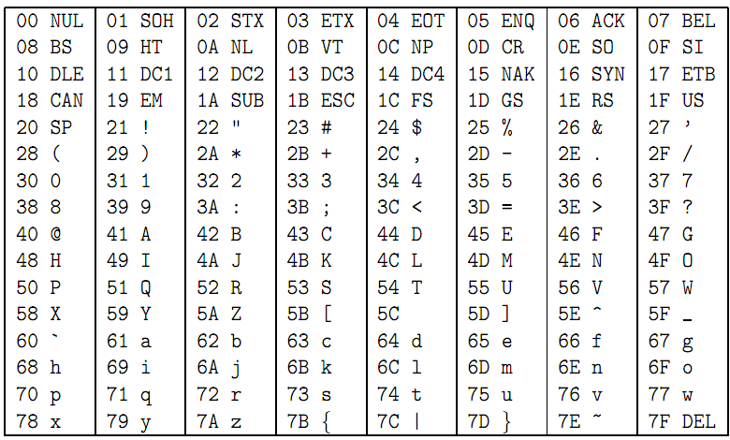

NOTES
In order to read strings, use service #8. You need to declare an array of bytes to hold the input, and set $a0 to its base address and $a1 to the maximum number of characters the user can enter. Upon return, the entered characters (along with the code of the ENTER key if pressed*) will be stored in the array and followed by a null terminator. Because of this null terminator, you should allocate an extra byte in the array. To set aside the space that we'll need to need to store the string, the .space directive can be used.

* Explore the case in which the user enters exactly as many characters as indicated in $a0: will the entry be appended with the ENTER code? Will it be null terminated?

COMPUTER ORGANIZATION AND ARCHITECTURE

LAB 6
Conversion of C Programs to MIPS Assembly Language

Task 1. Program to display Factorial of an integer, if user enters non-negative integer.

#include <stdio.h>
int main()
{
int n, count;
unsigned long long int factorial=1;
printf("Enter an integer: ");
scanf("%d",&n);
if ( n< 0)
printf("Error!!! Factorial of negative number doesn't exist.");
else
{
for(count=1;count<=n;++count) /* for loop terminates if count>n */
{
factorial*=count; /* factorial=factorial*count */
}
printf("Factorial = %lu",factorial);
}
return 0;
}

Solution

.data
task: .asciiz "\tfactorial.asm-- program to display factorial of an integer if user enters non-negative integer. \n"
name: .asciiz "By:\n Sikander 1094\n\n"
enterf: .asciiz "Enter Number to find its factorial :"
rfact: .asciiz "\nFactorial is " #string to be printed
.text

main:

li $v0, 4 # system call code for print_str
la $a0, task # address of string to print
syscall

li $v0, 4 # system call code for print_str
la $a0, name # address of string to print
syscall

## Get the number from user, put into $t0
li $v0, 4 # load syscall print_string into $v0
la $a0,enterf # prepare msg to print
syscall # make the syscall

li $v0, 5 # load syscall read_int into $v0
syscall # make the syscall
move $s1, $v0 # store the result of syscall into $t0
li $s0,1
li $s2,1
addi $s1,$s1,1
loop: slt $t0,$s0,$s1
beq $t0,$0,bottom

mul $s2,$s0,$s2
addi $s0,1
b loop
bottom:
li $v0, 4 # load syscall print_string into $v0
la $a0,rfact # prepare msg to print
syscall # make the syscall

li $v0, 1 # load syscall print_int into $v0
move $a0, $s2 # prepare t2 to print
syscall
li $v0, 10 # syscall code 10 is for exit.
syscall # make the syscall.

Task 2: Displaying Fibonacci sequence up to nth term where n is entered by user.

#include <stdio.h>
int main()
{
int count, n, t1=0, t2=1, display=0;
printf("Enter number of terms: ");
scanf("%d",&n);
printf("Fibonacci Series: %d+%d+", t1, t2); /* Displaying first two terms */
count=2; /* count=2 because first two terms are already displayed. */
while (count<n)
{
display=t1+t2;
t1=t2;
t2=display;
++count;
printf("%d+",display);
}
return 0;
}

Solution:

# fibanocci.asm-- Program to display fibanocci series upto number entered by user.

.data
task: .asciiz "\tfibanocci.asm-- Program to display fibanocci series upto number entered by user. \n"
name: .asciiz "By:\n Sikander \n\n"
str1: .asciiz "Please input the number (limit of series): "
str2: .asciiz "Fabanocci series : \n"
.globl main
.text
main:
li $v0, 4 # system call code for print_str
la $a0, task # address of string to print
syscall
li $v0, 4 # system call code for pint_str
la $a0, name # address of string to print
syscall
## Please input the first number:
la $a0, str1 # load the address of str1 into $a0
li $v0, 4 # load syscall print_int into $v0.
syscall # make the syscall.
## Get first number from user, put into $t0.
li $v0, 5 # load syscall read_int into $v0.
syscall # make the syscall.
move $t0, $v0 # move the number read into $t0.
la $a0, str2 # load the address of str1 into $a0
li $v0, 4 # load syscall print_int into $v0.
syscall # make the syscall.
li $t1,0
li $t2,1
li $s0,2
li $s1,0
move $a0, $t1 # move the number to print into $a0.
li $v0, 1 # load syscall print_int into $v0.
syscall # make the syscall.
again: li $a0,' ' # move the number to print into $a0.
li $v0,11 # load syscall print_int into $v0.
syscall # make the syscall.
move $a0, $t2 # move the number to print into $a0.
li $v0, 1 # load syscall print_int into $v0.
syscall # make the syscall.
slt $s2,$s0,$t0
beq $s2,$0,exit
add $s1,$t1,$t2
add $t1,$t2,$0
add $t2,$s1,$0
addi $s0,$s0,1
b again
exit: ## exit the program.
li $v0, 10 # syscall code 10 is for exit.
syscall # make the syscall.

Home Tasks

Task 3. Find and display all the factors of a number entered by an user.

#include <stdio.h>
int main()
{
int n,i;
printf("Enter a positive integer: ");
scanf("%d",&n);
printf("Factors of %d are: ", n);
for(i=1;i<=n;++i)
{
if(n%i==0)
printf("%d ",i);
}
return 0;
}

Task4. Program to display all prime numbers between Two interval entered by user.

#include <stdio.h>
int main()
{
int n1, n2, i, j, flag;
printf("Enter two numbers(intevals): ");
scanf("%d %d", &n1, &n2);
printf("Prime numbers between %d and %d are: ", n1, n2);
for(i=n1+1; i<n2; ++i)
{
flag=0;
for(j=2; j<=i/2; ++j)
{
if(i%j==0)
{
flag=1;
break;
}
}
if(flag==0)
printf("%d ",i);
}
return 0;
}

COMPUTER ORGANIZATION AND ARCHITECTURE

LAB 7

Floating Point Programming

Until now we have done only integer computation in MIPS, but in reality most of the computations also involve some floating point arithmetic. For this purpose MIPS supports various floating point instructions along with having 32 special floating point registers f0-f31.
Background
Floating-Point Architecture
In MIPS, floating point arithmetic is performed by a separate hardware chip, called Coprocessor 1. It has its own Arithmetic Unit and 32 floating-point registers, named $f0-$f31. All these registers are stored in a separate register file. This means that both ALU and FPU can work on different instructions independently, thus increasing the throughput of the system.
MIPS floating point hardware supports both single- and double-precision values. Just like integer registers, floating point registers are 32 bits long. Each register can hold a single-precision value or they can be combined to hold 16 double-precision numbers: $f0-$f1, $f2-$f3, ..., $f30-$f31.Today we will only handle single precision 32-bit numbers. All floating point instructions will end in .s, eg.,add.s, li.setc to represent single precision. The add.d or sub.d are double precision operations that we will not use today.

Floating-point programming conventions
Just like with integer registers, code written for floating point needs to follow specific conventions. Floating-point arguments are placed in registers $f12-$f15 for procedure calling and return values goes into $f0-$f1 by the register. Registers $f0- $f19 are caller-saved; $f20-$f31 are callee-saved. Remember In a progam with main and a single procedure, main is caller and procedure is callee.

Floating-Point Instructions (see reference at the end)
Floating-point MIPS instructions are very similar, both in structure and syntax, to the integer instructions. Many instructions can be used directly, but with a slight "accent." Just like with French and English, many words have similar spelling, but sound differently, as illustrated below.
add.d $f6, $f8, $f10
mul.s $f7, $f9, $f21
li.s $f5, 3.14159
mov.d $f26, $f28

Loading and storing data in memory.
MIPS provides friendly pseudo-instructions to memory accesses. First one to load and second one is to store.
l.s $f2, 0($a0) # $f5 = MEM[$a0]. This is a 32-bit value.
s.s $f4, 4($sp) # MEM[$sp] = $f4
Data transfer and conversions (Type Casting)
Note that the only permitted operands in floating-point arithmetic instructions are the $f registers. But real programs use both ALU and FPU. To accommodate this, there are several instructions for transferring data between integer and floating point registers.
a) Instructions to transfer raw data between integer registers and floating-point ones.
mtc1 $t0, $f0 # move to Coprocessor1 result: $f0 = $t0, conversion from integer to float
mfc1 $t0, $f0 # move from Coprocessor1 result: $t0 = $f0 . Conversion from float to integer, rounded
These instruction must follow cvt.s.wetc instructions. We will not do type casting in this lab.
Branches
Conditional branches are performed in two steps. First, perform the comparison. Second, branch, depending on the result. For example, the instruction branch to LOOP if $f2 < $f4 can be written as:
c.lt.s $f2, $f4 # if ($f2 < $f4) set a reserved comparison bit to 1, else set it to 0
bc1t LOOP # if (comp bit == 1) gotoLOOP
Note that the first instruction can use any of the six possible comparisons (.lt. is replaced with .gt, .ne, .ge, etc). Also, the name of the branch instruction is the abbreviation of "branch if the condition code of coprocessor1 is true" where true means set to 1.Similalry other instruction is bclf. Recall that the familiar set-if instructions use a programmer-specified register to store the result of the comparison. But since the result is either 0 or 1, one bit suffices to store the result. The branch instruction then uses the result produced by the previous instruction to decide what to do next.
Exercise 1
Type the following program .data (without comments of course)
Pi: .float 3.1415926 #Declare a single precision number Pi.
.text
.globl main
main:
la $t0, Pi # Load pointer (address of) a float variable in t0. Address is integer
l.s $f0,0($t0) # Load value of PI from data memory. Remember it is an INTEGER instruction.

It reads value of π = 3.1415926 in $f0. Now note the value of f0 in single precision register file.

sign:___, fraction _________________,exponent _________. Decimal value (reverse calculate)= _____

Bit→ | 31 | 30 | 29 | 28 | 27 | 26 | 25 | 24 | 23 | 22 | 21 | 20 | 19 | 18 | 17 | 16 | 15 | 14 | 13 | 12 | 11 | 10 | 9 | 8 | 7 | 6 | 5 | 4 | 3 | 2 | 1 | 0
Bit→ | sign | Biased Exponent |  |  |  |  |  |  |  | 23-bit Mantissa

(2) Mov value of f1 to f2 and read value of √¯13 in f1 using SYSCALL with $vo = 6. The Value returned is in $f0.
Bit→ | 31 | 30 | 29 | 28 | 27 | 26 | 25 | 24 | 23 | 22 | 21 | 20 | 19 | 18 | 17 | 16 | 15 | 14 | 13 | 12 | 11 | 10 | 9 | 8 | 7 | 6 | 5 | 4 | 3 | 2 | 1 | 0
Bit→ | sign | Biased Exponent |  |  |  |  |  |  |  | 23-bit Mantissa

fraction _________________, sign:___, exponent _________. Decimal Value: _______________

The following is an example of a C program for integer and floating numbers and its conversion in MIPS assembly. First see what the program is doing and then follow to exercise 2 on next page.
Side by Side Comparison of Integer and Floating Point Code
intsum_to_max_int(int max, intnums[]) {  int sum;  int k;  k = 1;  sum = 0;  while(sum<max)  {  sum += *nums[k];  k++;  }  return sum;  } | float sum_to_max_flt(float max, float nums[]) {  float sum;  int k;  k = 1;  sum = 0.0;  while(sum<max)  {  sum += *nums[k];  k++;  }  return sum;  }

Equivalent MIPS Code for Integer | Equivalent MIPS Code for FP
sum_to_max_int:  # k = $t0  # sum = $v0  li $t0, 1  li $v0, 0  loop: lw $t1, 0($a1)  mul $t1, $t1, $t0  add $v0, $v0, $t1  addi $a1, $a1, 4  slt $t2, $v0, $a0  bne $t2, $zero, loop  jr $ra | sum_to_max_flt:  # k = $t0  # sum = $f0  li $t0, 1  li.s $f0, 0.0  loop: l.s $f1, 0($a0)  mul.s $f1, $f1, $f2  add.s $f0, $f0, $f1  addi $a0, $a0, 4  c.lt.s $f0, $f12  bc1t loop  jr $ra

Now the Exercise 2:
Write down a MIPS program that utilizes the max function. Your program should contain an array of 10 floating point numbers whose address is passed in $a0 and the max float number is returned in $f12. You declare a floating point number in memory using the .float directive e.g.: .float 32.501. The program should print max of the ten integers(using SYSCALL with v0 = 2 and number in f12).
.data
myArray .float 3.14 2.56 5.79. 8.267 ……..
…
main:
…
jal max
print max using sys call
li $v0, 10 #stop the program
syscall

max:
…
write code to find max using branch instruction explained on page 1
Use integer registers to cycle through loop 10 times
…
jr $ra

COMPUTER ORGANIZATION AND ARCHITECTURE

LAB 8

Floating Point Arthmetics

Exercise 1:
Write a program to convert Fahrenheit to Celsius using the formula below:
Fahrenheit = Celsius * 9.0 / 5.0 + 32.0;
Write a function for this temperature conversion. Celsius value is be passed into the function as single-precision data and Fahrenheit value is returned also in single-precision. Remember to follow all the floating-point function conventions.

Exercise 2:

This exercise will familiarize you with floating point multiplication and division instructions. In this part you have to write a complete ‘UET Peshawar GPA calculator” program. The program should calculate GPA for a quarter only. When your program starts it should ask the unit and GPA in each of the four courses taken in the quarter. It should store all this information in memory. It should then compute the quarter GPA for the person and display it to the user. You should have a separate Compute GPA function which loads all necessary info from memory and computes the GPA. Note that you will need syscalls to input and output floats to the user. For this purpose you will have to refer to the old handout for the service code of these system calls. A more detailed instruction set is given at the end of this handout and may be useful for this exercise.

Exercise 3: Design a calculator that can perform addition, subtraction, multiplication and division on integer as well as floating point numbers.

COMPUTER ORGANIZATION AND ARCHITECTURE

LAB 9

Data Flow within the Data Path of MIPS processor using PathSim Simulator

Courtesy of Dr. Dalton R. Hunkins, Computer Science Department, St. Bonaventure University

Part A – How to of the Simulator
PathSim is a simulator for the simple data path discussed in Chapter 5 of the book Computer Organization and Design, 3rd ed., by David A. Patterson and John L. Hennessy. The simulator consists of html with embedded javascript, java and, therefore, is executed from a web page browser. The simulator was constructed by Dr. Dalton R. Hunkins, Computer Science Department, St. Bonaventure University.

PathSim is composed basically of four areas: the architecture schematic shown in the upper-lefthand panel, Instruction Input and Memory, Data Input and Memory, and Register Input and listing. Each of these is discussed in the following sections.

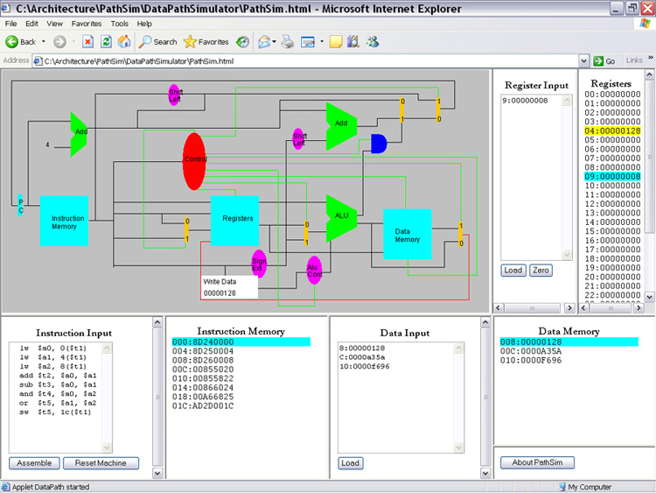
Fig: PathSim
The Architecture Schematic
The diagram of the architecture is basically that shown in Computer Organization and Design, 3rd ed., figure 5.24, page 314. The diagram given here is interactive. You can single-step through execution of MIPS instructions by left-clicking on the cyan rectangle labeled PC -- one instruction per click. The instructions being executed are those written in the Instruction Input box and successfully assembled. Also, the assembled instruction appearing in Instruction Memory area that was just executed is highlighted in cyan. You can see the effect of an instruction on the data path by placing the mouse over a data line and left-clicking. In doing so, a white box pops up displaying the current value on that data line.

Instruction Input and Memory
The assembly code you plan to execute is written into the Instruction Input box. Text-editing can be done within this text-area but you might find it more convenient to create your code in a plain-text editing tool apart from the simulator and copy-paste the code into the text-area. In this way, you can save your code to a file (the Instruction Input box does not provide for opening nor saving a file). There are two buttons appearing in the panel, namely, "Assemble" and "Reset Machine."
Pressing the Assemble button invokes the PathSim assembler, which, in turn, assembles the code appearing in the text-area. If the assembler should find an error according to its syntax, an alert box appears showing the "offending" line of code and the error. The PathSim assembler is a "first-error-and-out" assembler. This means you must fix an error and assemble the edited code before proceeding to the next error, if any. When your assembly code is error free, an alert box appears stating in essence that the code assembled and loaded successfully. The machine instructions that are assembled from your code are displayed in the Instruction Memory area.
Pressing the Reset Machine button resets the program counter (PC) to 0 and resets the particular data addresses and registers to what was last loaded; all others are reset to zero. This means that it is not necessary to re-load these using their respective load buttons. If no values were previously loaded, then all data addresses and registers are reset to 0.

Syntax of Assembly Code
Assembly code for PathSim does not contain any labels for branch points (e.g. loop:). Instead of labels, we use strings of hexadecimal digits for the offset of a branch instruction and the absolute address for a jump instruction. Since these and numeric constants for offsets in memory references (e.g., F8($t0)) can only be hexadecimal, you do not write the usual prefix "0x" before the hexadecimal value. Also, do not use directives such as .text, .data, etc. In turn, storing values in data memory is done through Data Input. Except for these differences, the rest of the syntax for the PathSim assembler is the same as for a MIPS assembler (e.g. QtSpim). Last, each line of code must be terminated with an end-of-line marker.

Data Input and Memory
As with the Instruction Input box, the Data Input box contains a text-area. Therefore, you can type your data values here. But you may also want to consider using a separate plain text editing tool and copy paste into the text area. The format for a line that is entered into the input box is memoryAddress: value. Both the memoryAddress and the value are strings of hexadecimal digits. The string for the value must contain exactly 8 hex digits. There cannot be any spaces surrounding the colon (:) nor any other place in the line. Also, there cannot be any empty lines (i.e., null strings terminated by an end-of-line marker). Last, each data input line must be terminated with an end-of-line marker. The Data Memory area is for displaying your data values that are loaded into data memory when you press the "Load" button.
When you step through the execution of your instructions, whenever a reference is made to a word in data memory, the word is highlighted within the display area. If the reference is for reading, the highlight is cyan; if it is a write-reference, then the highlight is yellow.

Register Input and Registers
As with the other input boxes, the Register Input box contains a text-area. Therefore, you can type your register values here. Of course, we only need to do this when we want to initialize a register with a value other than zero (0 is the default initial value). The format for a line that is entered into the input box is registerNumber: value. Similar to data values, a register value is a string of exactly 8 hexadecimal digits. On the other hand, the registerNumber must be written as a decimal (base 10) number, 0 through 31. Also, there cannot be any spaces surrounding the colon (:) nor any other place in the line. Last, each input line must be terminated with an end-of-line marker and there cannot be any empty lines. The Register list shows the register values either as initialized with zero or as loaded from the Register Input box when you press the "Load" button.
When you step through the execution of your instructions, whenever a reference is made to a register, the register-value is highlighted within the display area. If the reference is for reading, the highlight is cyan; if it is a write-reference, then the highlight is yellow.

Sample Code (for Part B)
#Assembly Code
lw $a0, 0($t1)
lw $a1, 4($t1)
lw $a2 8($t1)
add $t2, $a0, $a1
sub $t3, $a0, $a4
and $t4, $a0, $a2
or $t5, $a1, $a2
sw $t5, 1c($t1)

#Data Memory
8:00000128
C:0000a35a
10:0000f696

#Register Values
9:00000008

Part B
Observing Data Flow within the Data Path Simulator (PathSim)

Steps
- Use your browser to open the data path simulator PathSim.html. The page is resident in the folder PathSim\DataPathSimulator along with other required html and jar files.
- Select and copy the snippet of assembly code appearing in the box below and paste it into the Instruction Input box in PathSim. The Instruction Input box is a text box and, therefore, you can do some text-editing within the box. Next, assemble the set of instructions by pressing the Assemble button. The snippet of code is written intentionally with two syntax errors. Thus, when you assemble the code, an alert box will popup, showing a line containing an error. The PathSim assembler is a “first error and out” assembler and, therefore, you will only see one error at a time. Now, fix the first error and (re)assemble the edited code. Since there is another error in the code, you will see another alert box showing the second error. Fix the second error, assemble the edited code and it should now assemble successfully. If another error should appear and on the last line, it is due to a missing end-of-line marker. PathSim expects that ALL lines are terminated with an end-of-line.
- Select and copy the three lines of words with addresses given after the comment #Data Memory and paste it into the Data Input box. Press the Load button within the Data Input box; the data should load successfully. If not, check to see that there are neither empty lines nor spaces within the text. Also, make sure the third line is terminated with an end-of-line marker.
- Select and copy the one word with register number appearing after the comment #Register Values and paste it into the Register Input box. Press the Load button within the Register Input box; the word should load successfully into the specified register. If not, make sure that the line is terminated with an end-of-line marker and there are not empty lines or spaces.
- Place the mouse over the rectangle marked PC shown in the data path diagram and left-click the mouse. Left-clicking on PC steps through the machine instructions that were assembled from the snippet of assembly code, one instruction per click. As you step through the code, place the mouse over data lines shown in the data path diagram and left-click the mouse. A popup box will appear showing the value which is on that line. Observe the values placed on data lines as you step through each instruction. Record only the values as indicated in the tables given at the end of this document. But make sure you also understand how the values are established for all instructions.
- Close the browser and PathSim after you have stepped through each of the machine instructions and recorded your observed values.
Name:______________________ Class/Reg No._______________

 | add $t2, $a0, $a1
 | Mux | Registers | Sign Ext | Mux | Alu Cont | ALU
Input | I[20-16] | I{25-21] | I{15-0] | ReadData2 | I[5-0] | ReadData1
Input | I[15-11] | I[20-16] |  | From SignExt |  | From Mux
Input |  | WriteReg
Input |  | WriteData
Control | RegDst | RegWrite |  | ALUSrc | ALUOp | ALUControl
Output | WriteReg | ReadData1 |  |  | ALUControl | Zero
Output |  | ReadData2 |  |  |  | ALUResult

 | sub $t3, $a0, $a1
 | Mux | Registers | Sign Ext | Mux | Alu Cont | ALU
Input | I[20-16] | I{25-21] | I{15-0] | ReadData2 | I[5-0] | ReadData1
Input | I[15-11] | I[20-16] |  | From SignExt |  | From Mux
Input |  | WriteReg
Input |  | WriteData
Control | RegDst | RegWrite |  | ALUSrc | ALUOp | ALUControl
Output | WriteReg | ReadData1 |  |  | ALUControl | Zero
Output |  | ReadData2 |  |  |  | ALUResult

 | and $t4, $a0, $a2
 | Mux | Registers | Sign Ext | Mux | Alu Cont | ALU
Input | I[20-16] | I{25-21] | I{15-0] | ReadData2 | I[5-0] | ReadData1
Input | I[15-11] | I[20-16] |  | From SignExt |  | From Mux
Input |  | WriteReg
Input |  | WriteData
Control | RegDst | RegWrite |  | ALUSrc | ALUOp | ALUControl
Output | WriteReg | ReadData1 |  |  | ALUControl | Zero
Output |  | ReadData2 |  |  |  | ALUResult

 | or $t5, $a1, $a2
 | Mux | Registers | Sign Ext | Mux | Alu Cont | ALU
Input | I[20-16] | I{25-21] | I{15-0] | ReadData2 | I[5-0] | ReadData1
Input | I[15-11] | I[20-16] |  | From SignExt |  | From Mux
Input |  | WriteReg
Input |  | WriteData
Control | RegDst | RegWrite |  | ALUSrc | ALUOp | ALUControl
Output | WriteReg | ReadData1 |  |  | ALUControl | Zero
Output |  | ReadData2 |  |  |  | ALUResult

COMPUTER ORGANIZATION AND ARCHITECTURE

LAB 10

Introduction to MODELSIM and Gate Level Modeling

Objectives:
Introduction to MODELSIM

Software used:
MODELSIM

MODELSIM:
MODELSIM is a simulator which can be used for the simulations of both VHDL and Verilog HDL. It has the following interface.

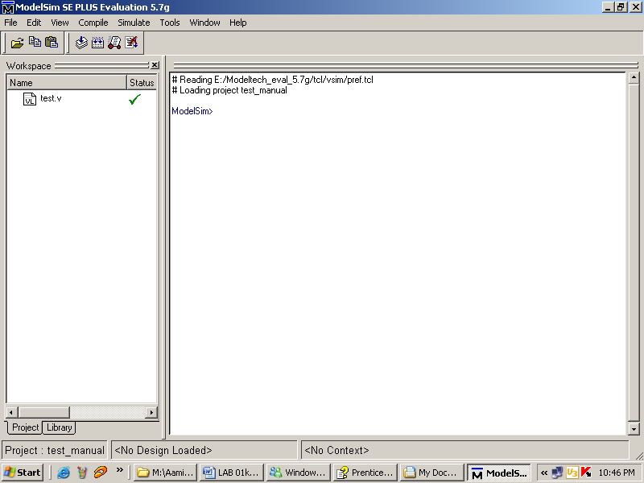

How to use MODELSIM?

Step 1
Creating a new project
Select File > New > Project (Main window) to create a new project. This opens the Create Project dialog. The dialog includes these options:
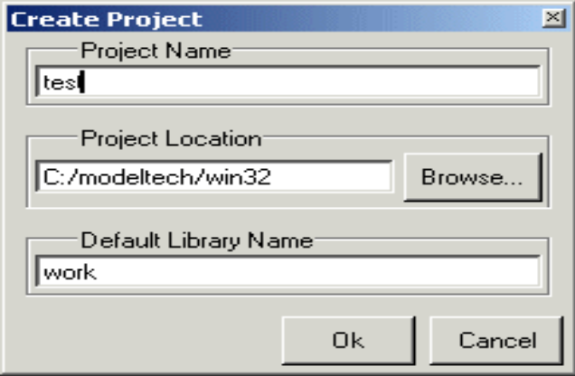

• Project Name
The name of the new project.
• Project Location
The directory in which the .mpf file will be created.
• Default Library Name
The name of the working library.
You can generally leave the Default Library Name set to "work." The name you specify will be used to create a working library subdirectory within the Project Location.

After selecting OK, you will see a blank Project tab in the workspace area of the Main window and the Add Items to the Project dialog.

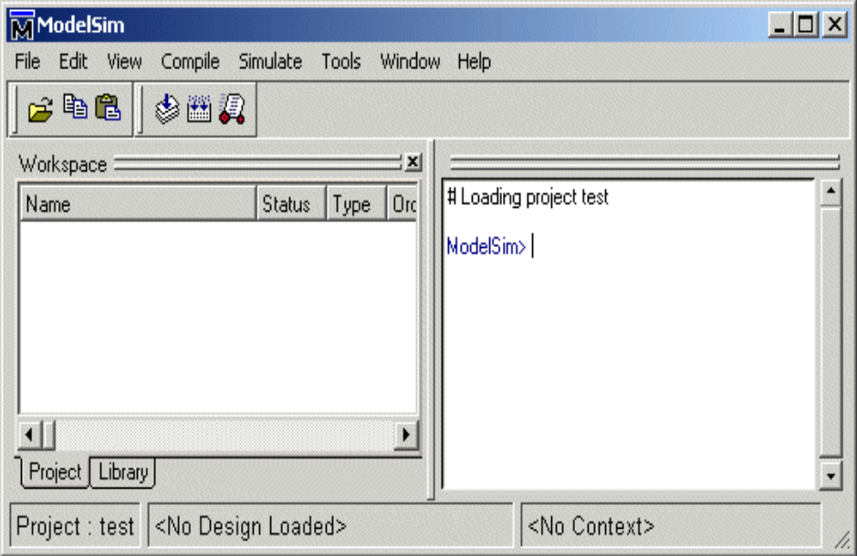

The name of the current project is shown at the bottom left corner of the Main window.

Step 2
Adding items to the project
The Add Items to the Project dialog includes these options:
- Create New File
Create a new VHDL, Verilog, Tcl, or text file using the Source window. See below for details.
- Add Existing File
Add an existing file. See below for details.
- Create Simulation
Create a Simulation Configuration that specifies source files and simulator options. See
- Create New Folder
Create an organization folder.
Create New File
The Create New File command lets you create a new VHDL, Verilog, Tcl, or text file using the Source window. You can also access this command by selecting File > Add to Project > New File (Main window) or right-clicking (2nd button in Windows; 3rd button in UNIX) in the Project tab and selecting Add to Project > New File.

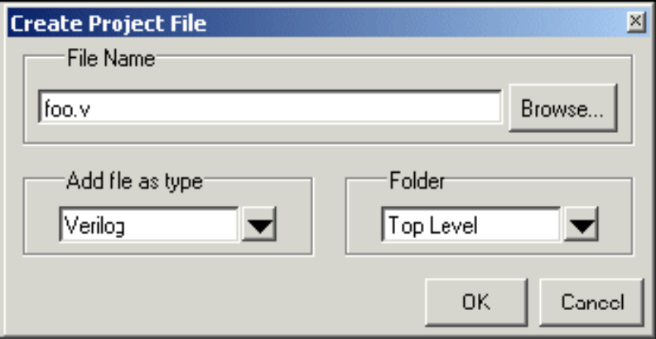

The Create Project File dialog includes these options:
- File Name
The name of the new file
- Add file as type
Add the type of the new file. Select VHDL, Verilog, TCL, or text.
- Folder
The organization folder in which you want the new file placed. You must first create folders in order to access them here

When you select OK, the Source window opens with an empty file, and the file is listed in the Project tab of the Main window workspace.

Add Existing File
You can also access this command by selecting File > Add to Project > Existing File (Main window) or by right-clicking (2nd button in Windows; 3rd button in UNIX) in the Project tab and selecting Add to Project > Existing File.
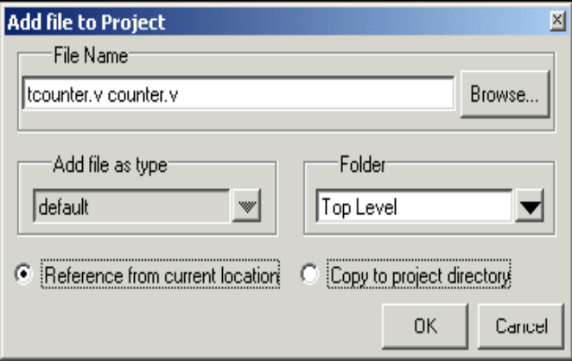
The Add file to Project dialog includes these options:
- File Name
The name of the file to add. You can add multiple files at one time.
- Add file as type
The type of the file. "Default" assigns type based on the file extension (e.g., .v is type Verilog).
- Folder
The organization folder in which you want the file placed. You must first create folders in order to access them here.
Choose whether to reference the file from its current location or to copy it into the project directory. When you select OK, the file(s) is listed in the Project tab of the Main window workspace.

Step 3
Compiling the files
The question marks next to the files in the Project tab denote either the files haven’t been compiled into the project or the source has changed since the last compile. To compile the files, select Compile > Compile All (Main window) or right click in the Project tab and select Compile > Compile All.

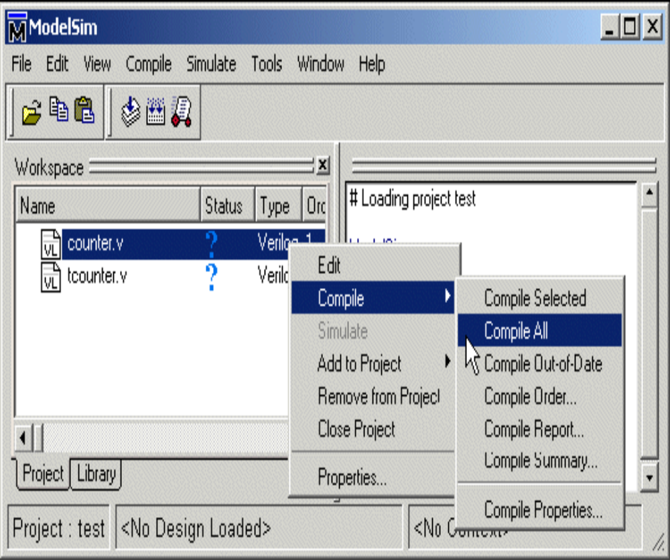

Once compilation is finished, click the Library tab, expand library work by clicking the "+", and you’ll see the two compiled design units.
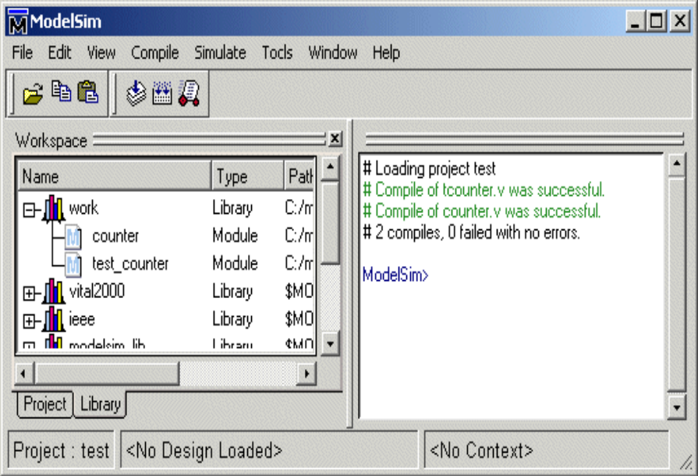

Step 4
Simulating a design

To simulate one of the designs, either double-click the name or right-click the name and select Simulate. A new tab appears showing the structure of the active simulation. At this point you are ready to run the simulation and analyze your results. You often do this by adding signals to the Wave window and running the simulation for a given period of time.

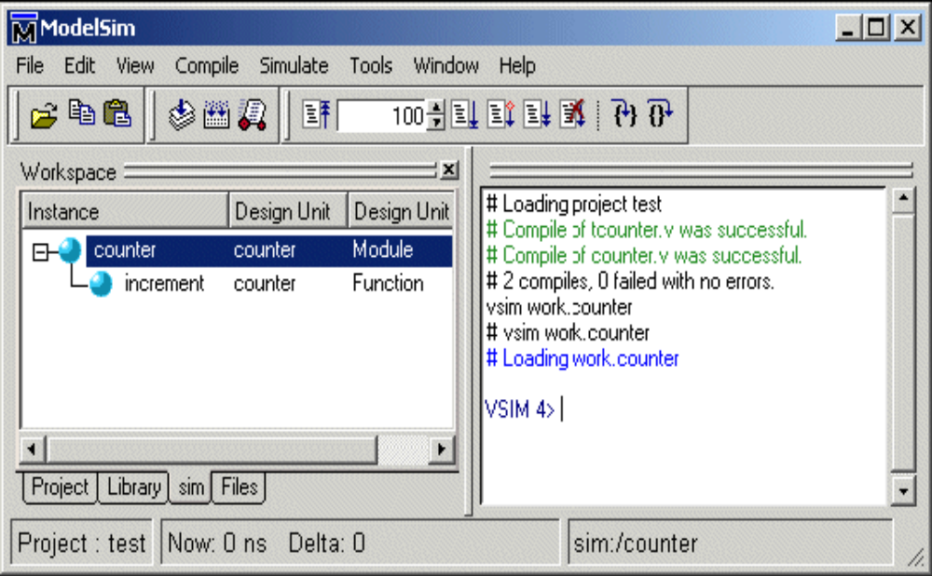

Program:
Example for the module instantiation

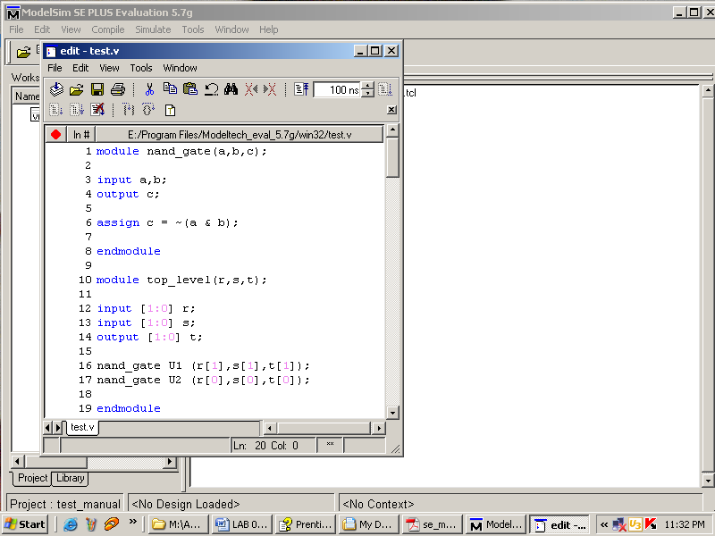

Lab tasks:
- Implement a buffer at the gate level.
- Implement an inverter at the gate level.
- Implement an OR gate using a NAND gates.
- Implement the following equation where z is output and x1, x2, x3, x4, and x5 are inputs of the circuit.
z = ( y1 + y2 )’
y1 = x1.x2
y2 = (x3.x4.x5)’

